**Help**

**Directions**

Leslie has been struggling in Algebra so her fellow classmates have all agreed to help her out by giving her the left-over tenths of points from their own averages. For example, if John's average is 92.3, Leslie will get .3 points added to her average. If Joe's average is 72.7, Leslie will get .7 points. There are ten other students in Leslie's class.

Write a program that will allow the teacher to input Leslie's average and then the averages of her 10 classmates rounded to the nearest tenth. The program should then compute the number of points that Leslie will receive and add that value to her average.

To help calculate the extra points Leslie will receive you can use the Math class's floor method. The **floor** method returns the largest double value that is less than or equal to the given number and is equal to an integer. In other words, it rounds down. The table below shows the results after applying the floor method to various numbers.

|  |  |
| --- | --- |
| **Before** | **After** |
| 92.5 | 92.0 |
| 76.2 | 76.0 |
| 69.9 | 69.0 |
| -24.7 | -25.0 |

Suppose one of the students in Leslie's class is assigned the variable name **s1Avg** and has an average of 98.6. Below is the code that extracts the .6 from the grade and adds it to a variable named **extraPoints**.

extraPoints += s1Avg - Math.floor(s1Avg);

By subtracting student one's original average by the floor of the average you get the following result

98.6 - 98.0 = .6

This value is added to Leslie's extra points total.

Problem Decomposition

Using the structure chart below decomposes the problem into the following three methods: **getAverages**,**calculatePoints**, and **printResults**.

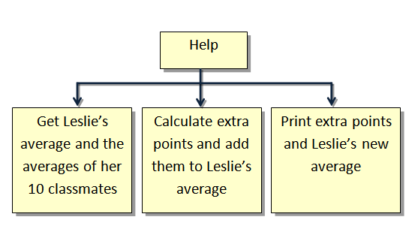

Stub Program

Start by creating a stub program that includes all three methods. Include println statements within each method that print the name of the method when it is executed. Refer to sample run below.

**Source File**

Help.java

**Stub Program Sample Run**

-----------------

getAverages

-----------------

-----------------

calculatePoints

-----------------

-----------------

printResults

-----------------

**Sample Run**

-----------------

getAverages

-----------------

Leslie's average -->68.2

Student 1 average -->98.7

Student 2 average -->95.5

Student 3 average -->87.6

Student 4 average -->78.3

Student 5 average -->91.2

Student 6 average -->85.8

Student 7 average -->75.6

Student 8 average -->99.9

Student 9 average -->78.1

Student 10 average -->83.7

-----------------

calculatePoints

-----------------

-----------------

printResults

-----------------

Points = 5.3999999999999915

New Average = 73.6